Word Break
Given an input string and a dictionary of words, find out if the input string can be segmented into a space-separated sequence of dictionary words. See following examples for more details.
Example:
Dict[] = { “leet”, “code” }
String = “leetcode”
O/p: possible

Answer:
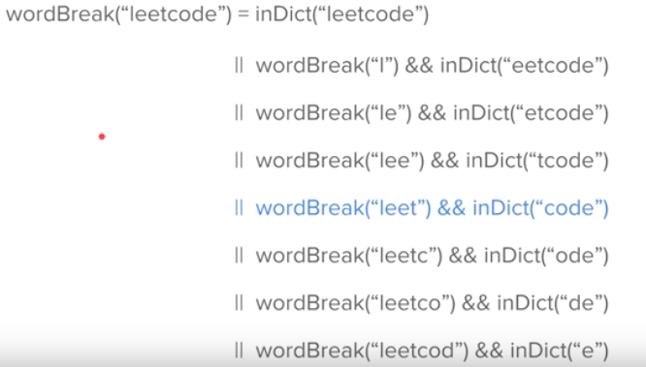
A recursive solution can be written as follows:

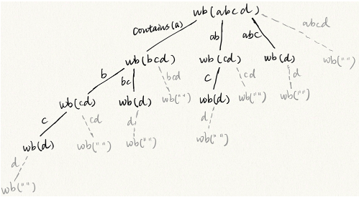
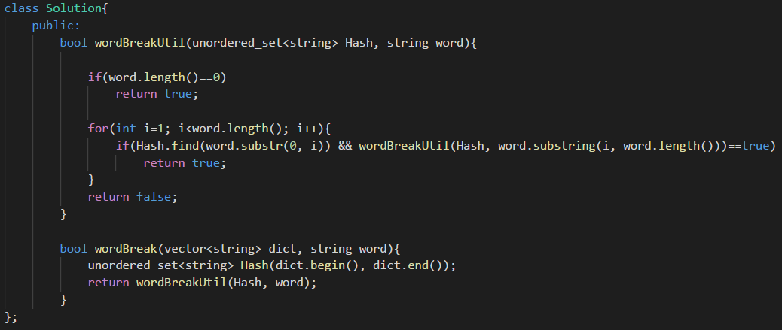

From the code if (Hash.find(s.substring(0, i)!=Hash.end()) && Util(s.substring(i), set)) { }, we can see that only if the wordDict contains the prefix, the recursion function can go down to the next level. So on the figure above, string on the edge means the wordDict contains that string. All the gray node with empty string cannot be reached because if the program reaches one such node, the program will return, which lead to some nodes right to it will not be reached. So the conclusion is for a string with length 4, the recursion tree has 8 nodes (all black nodes), and 8 is 2^(4-1). So to generalize this, for a string with length n, the recursion tree wil have 2^(n-1) nodes, i.e., the time complexity is O(2^n).

